**Вопросы 1**

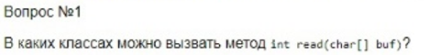

* **java.io.Reader**
* **java.io.BufferedReader**
* **java.io.FileReader**
* **java.io.InputStreamReader**
* **java.io.CharArrayReader**
* **java.io.PipedReader**
* **java.io.StringReader**

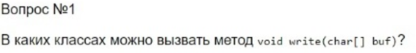

* **java.io.Writer**
* **java.io.BufferedWriter**
* **java.io.FileWriter**
* **java.io.OutputStreamWriter**
* **java.io.CharArrayWriter**
* **java.io.PipedWriter**
* **java.io.StringWriter**



* **java.io.Reader**
* **java.io.Writer**
* **java.io.BufferedReader**
* **java.io.BufferedWriter**
* **java.io.FileReader**
* **java.io.FileWriter**
* **java.io.InputStreamReader**
* **java.io.OutputStreamWriter**
* **java.io.CharArrayReader**
* **java.io.CharArrayWriter**
* **java.io.PipedReader**
* **java.io.PipedWriter**
* **java.io.StringReader**
* **java.io.StringWriter**



* **java.io.InputStream**
* **java.io.OutputStream**
* **java.io.BufferedInputStream**
* **java.io.BufferedOutputStream**
* **java.io.ByteArrayInputStream**
* **java.io.ByteArrayOutputStream**
* **java.io.DataInputStream**
* **java.io.DataOutputStream**
* **java.io.FileInputStream**
* **java.io.FileOutputStream**
* **java.io.PipedInputStream**
* **java.io.PipedOutputStream**
* **java.io.SequenceInputStream**

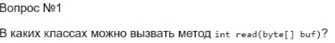

* **java.io.InputStream**
* **java.io.BufferedInputStream**
* **java.io.ByteArrayInputStream**
* **java.io.DataInputStream**
* **java.io.FileInputStream**
* **java.io.PipedInputStream**
* **java.io.SequenceInputStream**

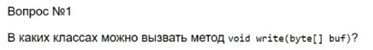

* **java.io.OutputStream**
* **java.io.BufferedOutputStream**
* **java.io.ByteArrayOutputStream**
* **java.io.DataOutputStream**
* **java.io.FileOutputStream**
* **java.io.PipedOutputStream**

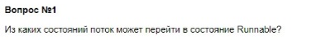

New

Waiting

Blocked

Timed_Waiting

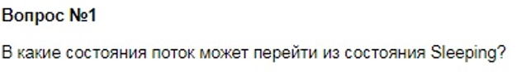

Runnable

Terminated

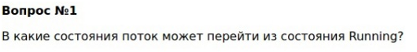

Terminated

Runnable

Timed_Waiting

Waiting

Blocked



Runnable

Running

Blocked

Waiting

Timed_Waiting

Sleeping

**Вопросы 2**

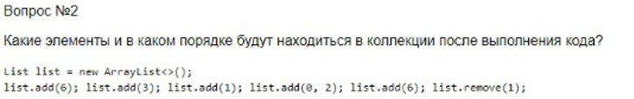

2 3 1 6

List - add(index,object) or (object)

- remove(index)

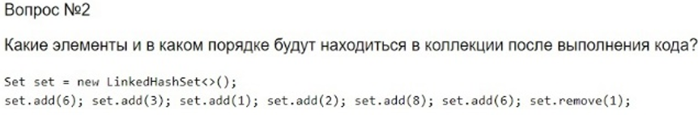

6 3 2 8

Set – add(object)

- remove(object)

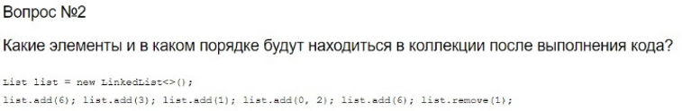

2 3 1 6

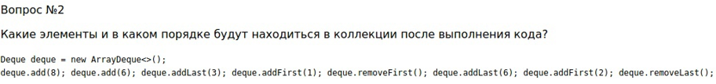

2 8 6 3

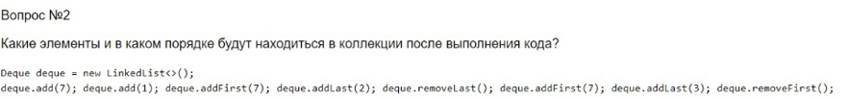

7 7 1 3

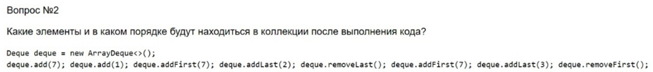

7 7 1 3



2 8 6 3



Factory Method



Observer – наблюдатель (Minecraft enjoyer)



Command



State – шаблон Состояние



Chain of Responsibility – цепочка ответственности



Facade



Proxy

**Вопросы 3**

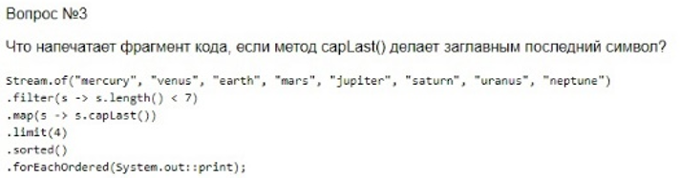

eartH

marS

saturN

venuS

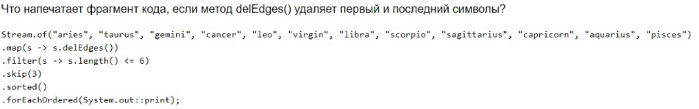

ance

cropi

e

ibr

irgi

isce

quariu

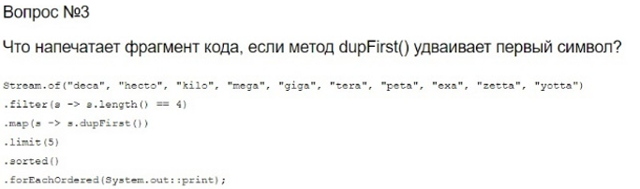

ddeca

ggiga

kkilo

mmega

ttera

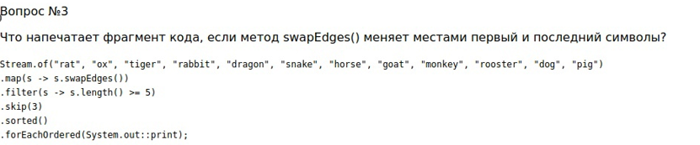

enaks

eorsh

rooster

yonkem

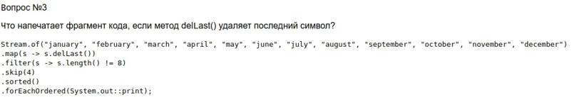

augus

decembe

jul

jun

ma

novombe

octobe

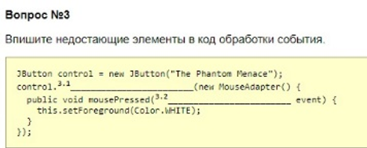

3.1 addMouseListener

3.2 MouseEvent

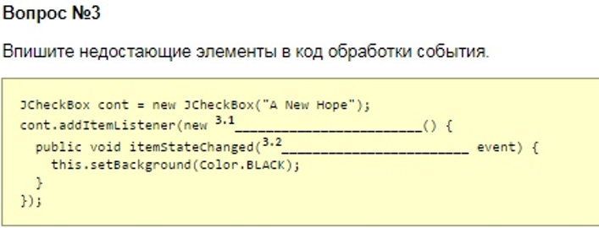

3.1 ItemListener

3.2 ItemEvent

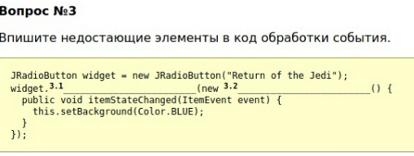

3.1 addItemListener

3.2 ItemListener

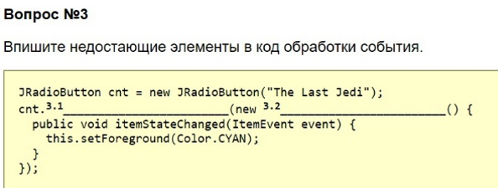

3.1 addItemListener

3.2 ItemListener

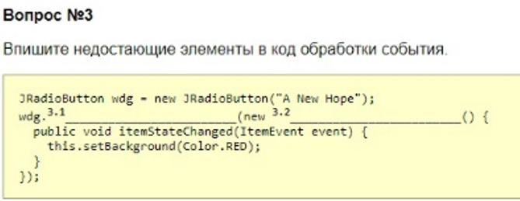

3.1 addItemListener

3.2 ItemListener

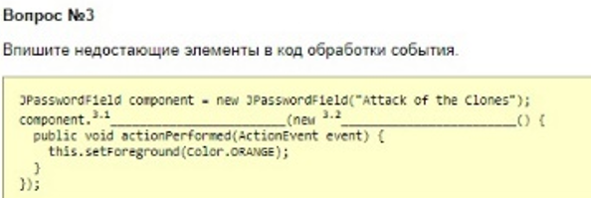

3.1 addActionListener

3.2 ActionListener

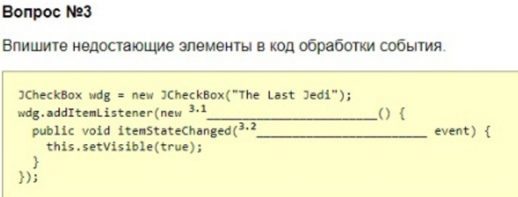

3.1 ItemListener

3.2 ItemEvent

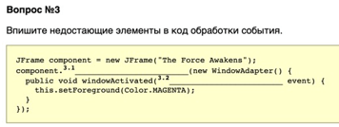

3.1 addWindowListener

3.2 WindowEvent

**Вопросы 4**

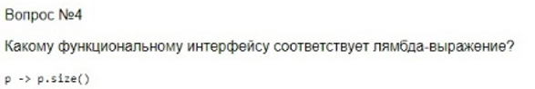

**java.util.function.Function**

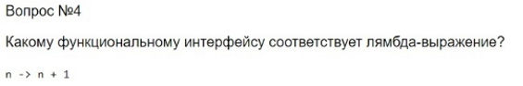

**java.util.function.UnaryOperator**

**java.util.function.Function**

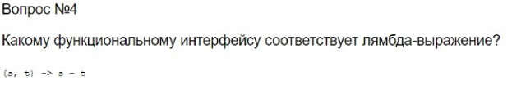

**java.util.function.BinaryOperator**

**java.util.function.Function**

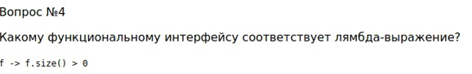

**java.util.function.Predicate**

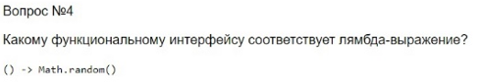

**java.util.function.Supplier**

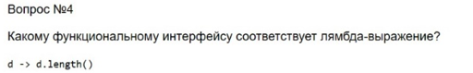

**java.util.function.Function**

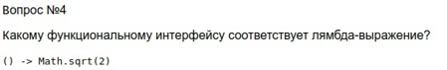

**java.util.function.Supplier**

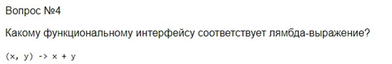

**java.util.function.BinaryOperator**

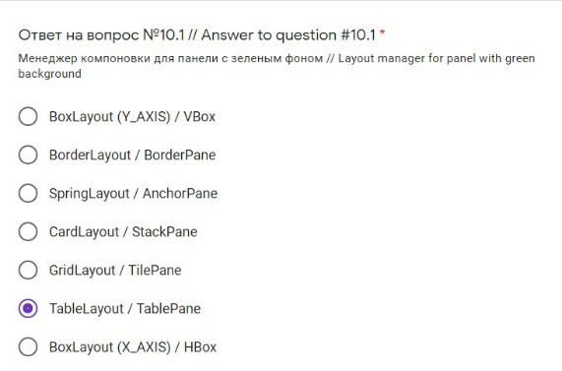

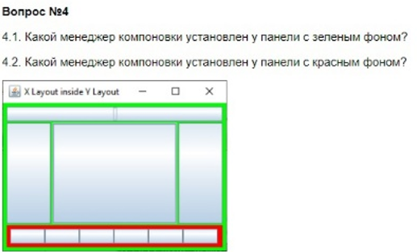

4.1 BorderLayout

4.2 BoxLayout(X-AXIS)

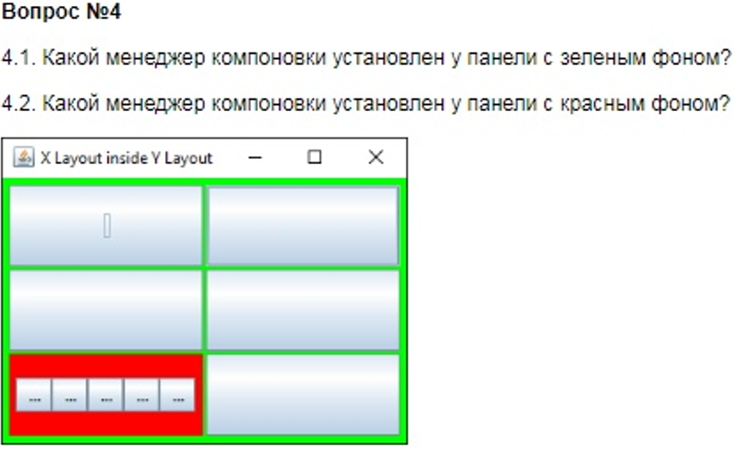

4.1 GridLayout

4.2 GridLayout ???

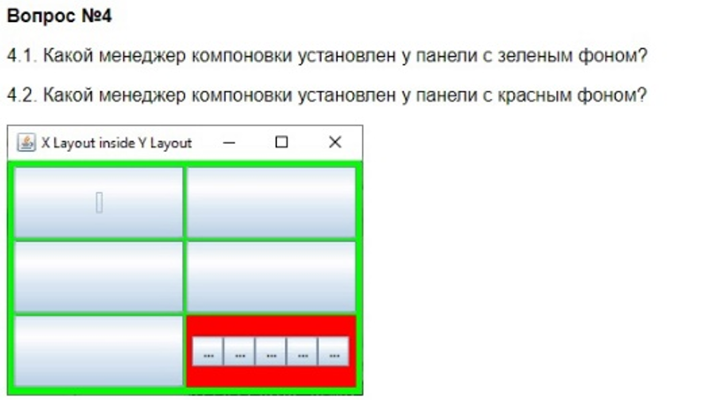

4.1 GridLayout

4.2 GridLayout ???

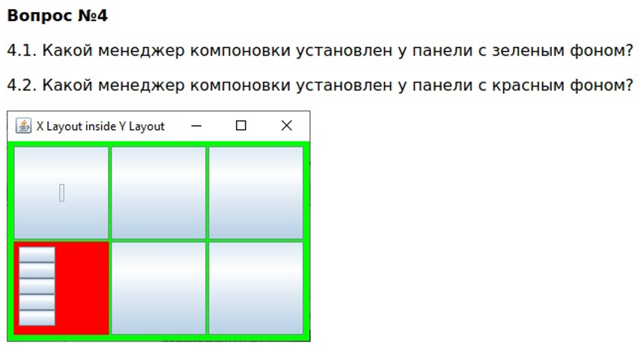

4.1 GridLayout

4.2 BoxLayout(Y_AXIS)

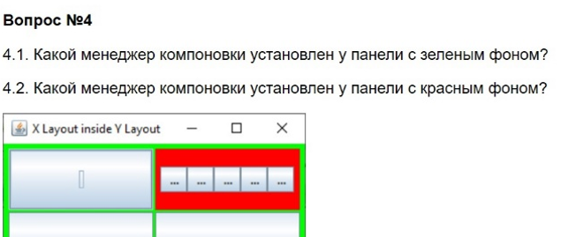

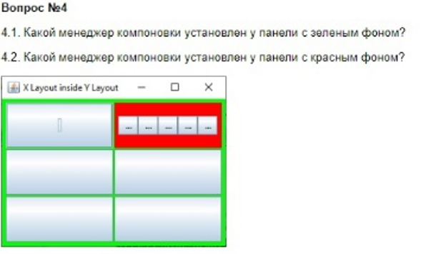

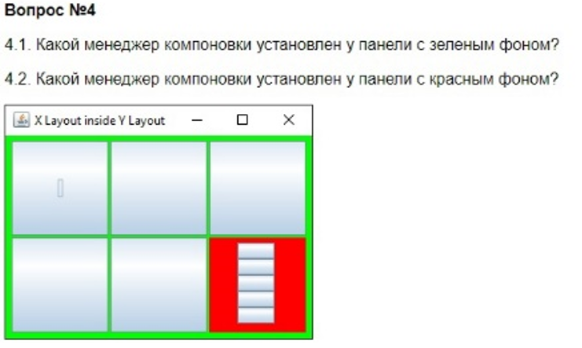

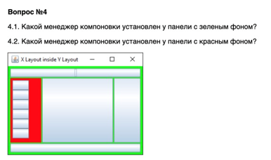

**Вопросы 5**

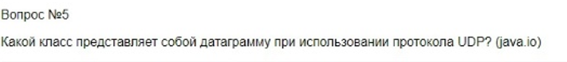

**java.net.DatagramPacket**

**java.nio.DatagramChannel**



**java.net.ServerSocket**

**java.nio.ServerSocketChannel**



**java.net.Socket**

**java.nio.SocketChannel**



**java.net.Socket**

**java.nio.SocketChannel**

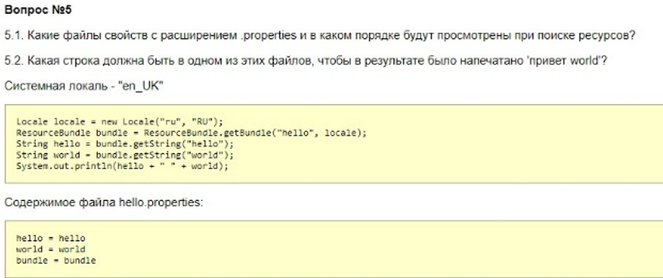**5.1 hello_ru_RU.properties**

**hello_ru.properties**

**hello_en_UK.properties**

**hello_en.properties**

**hello.properties**

**5.2 hello = привет**

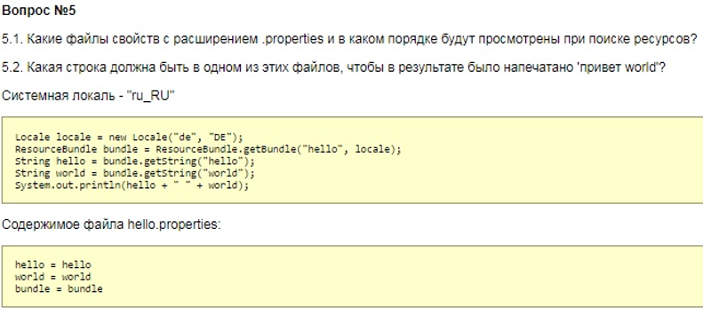

**5.1 hello_de_DE.properties**

**hello_de.properties**

**hello_ru_RU.properties**

**hello_ru.properties**

**hello.properties.**

**5.2 hello = привет**

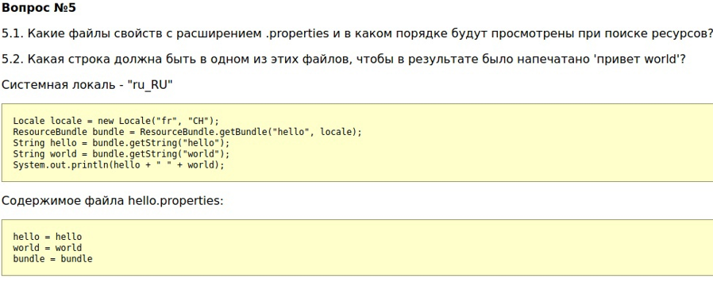

**5.1 hello_fr_CH.properties**

**hello_fr.properties**

**hello_ru_RU.properties**

**hello_ru.properties**

**hello.properties**

**5.2 hello = привет**

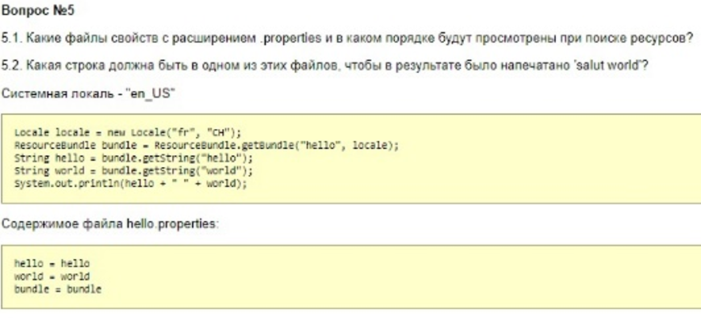

**5.1 hello_fr_CH.properties**

**hello_fr.properties**

**hello_en_US.properties**

**hello_en.properties**

**hello.properties**

**5.2 hello = salut**

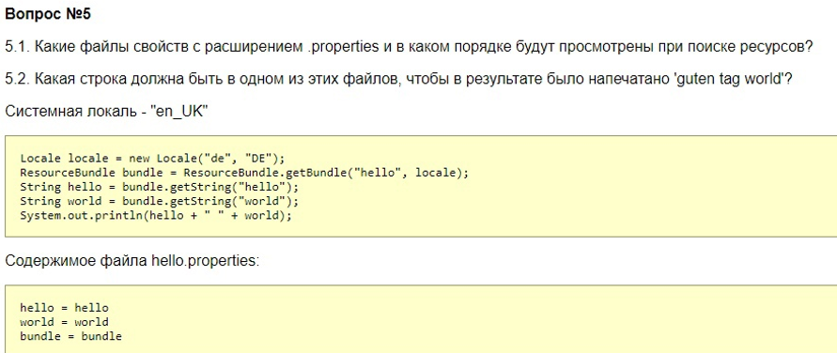

**5.1 hello_de_DE.properties**

**hello_de.properties**

**hello_en_UK.properties**

**hello_en.properties**

**hello.properties**

**5.2 hello = guten tag**

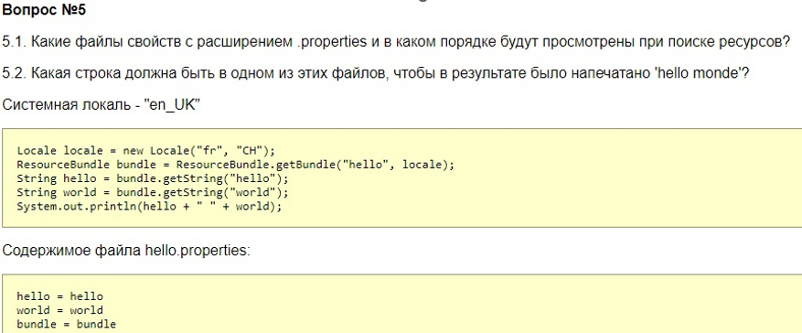

**5.1 hello_fr_CH.properties**

**hello_fr.properties**

**hello_en_UK.properties**

**hello_en.properties**

**hello.properties**

**5.2 world = monde**

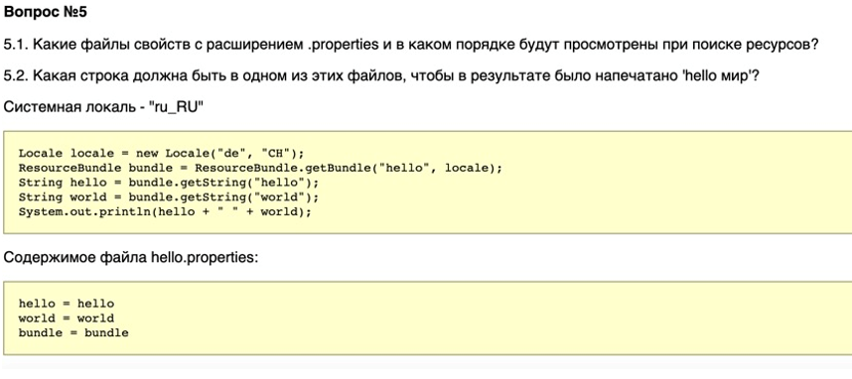

**5.1 hello_de_CH.properties**

**hello_de.properties**

**hello_ru_RU.properties**

**hello_ru.properties**

**hello.properties**

**5.2 world = мир**

**Вариант 0E**

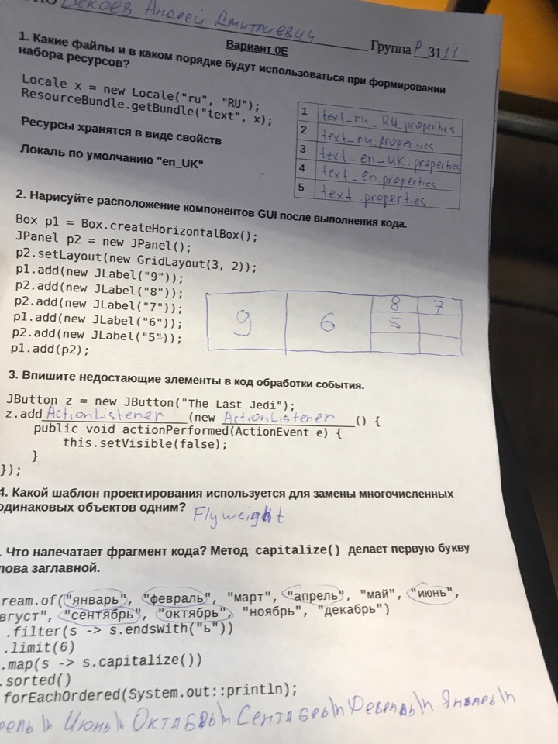

**Вариант 0A**

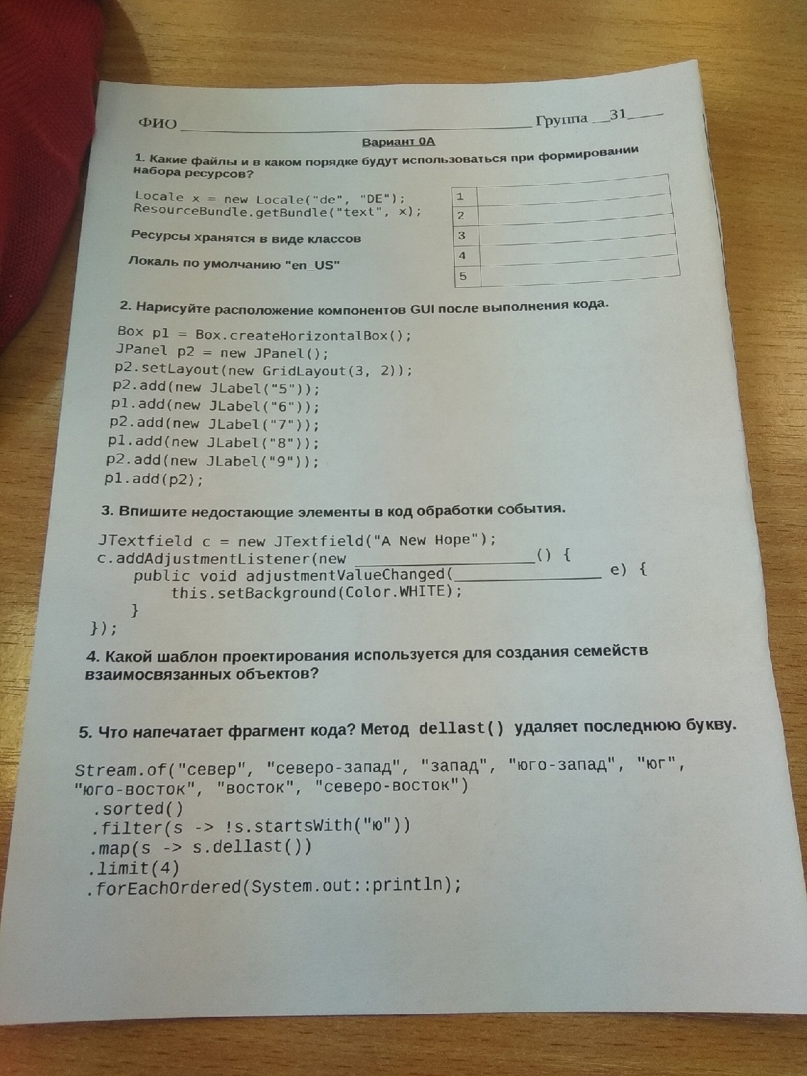

**Вариант 04**

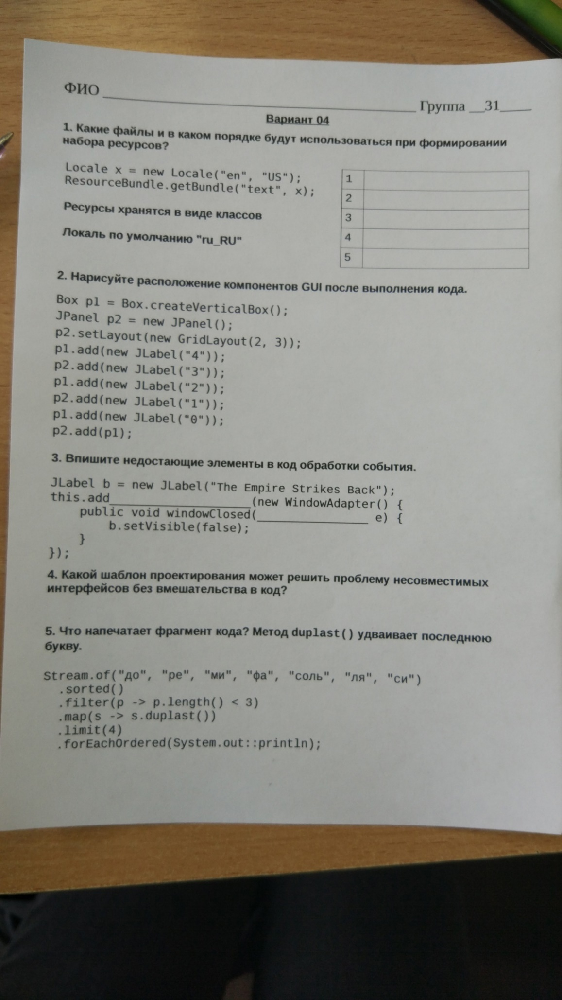

**Вариант 03**

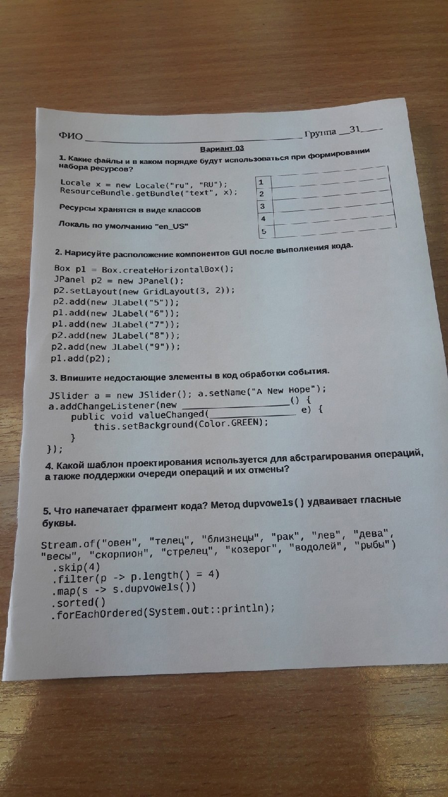

**Вариант 0C**

